Tomcat image:
Links:
https://hub.docker.com/_/tomcat
https://forums.docker.com/t/tomcat-give-error-404/95130

docker run -d -v /home/ubuntu/NPR:/usr/local/tomcat/webapps -p 8888:8080 tomcat:9.0
docker ps
docker exec -it d7875444ded5 /bin/bash
mv webapps.dist/* webapps
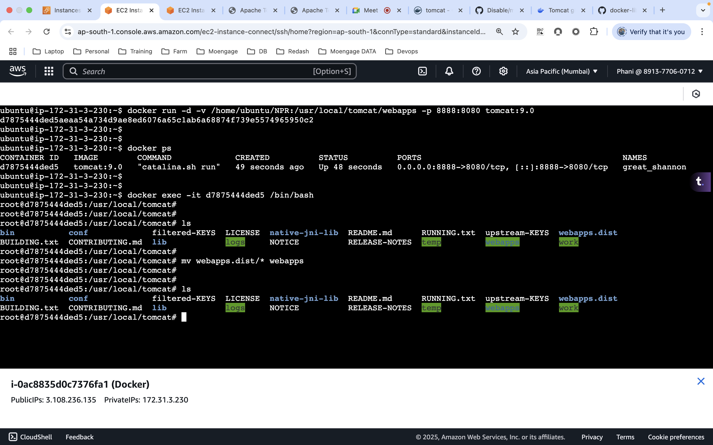

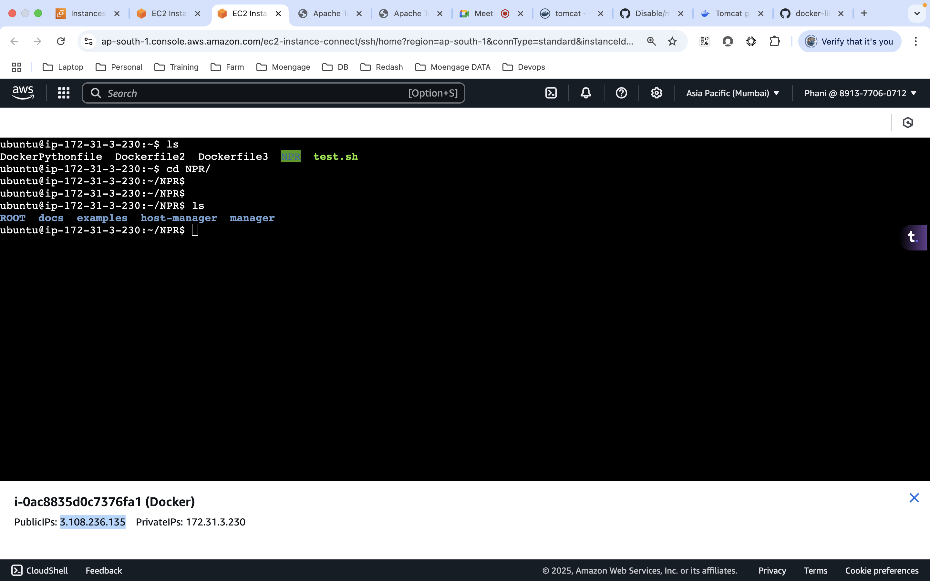

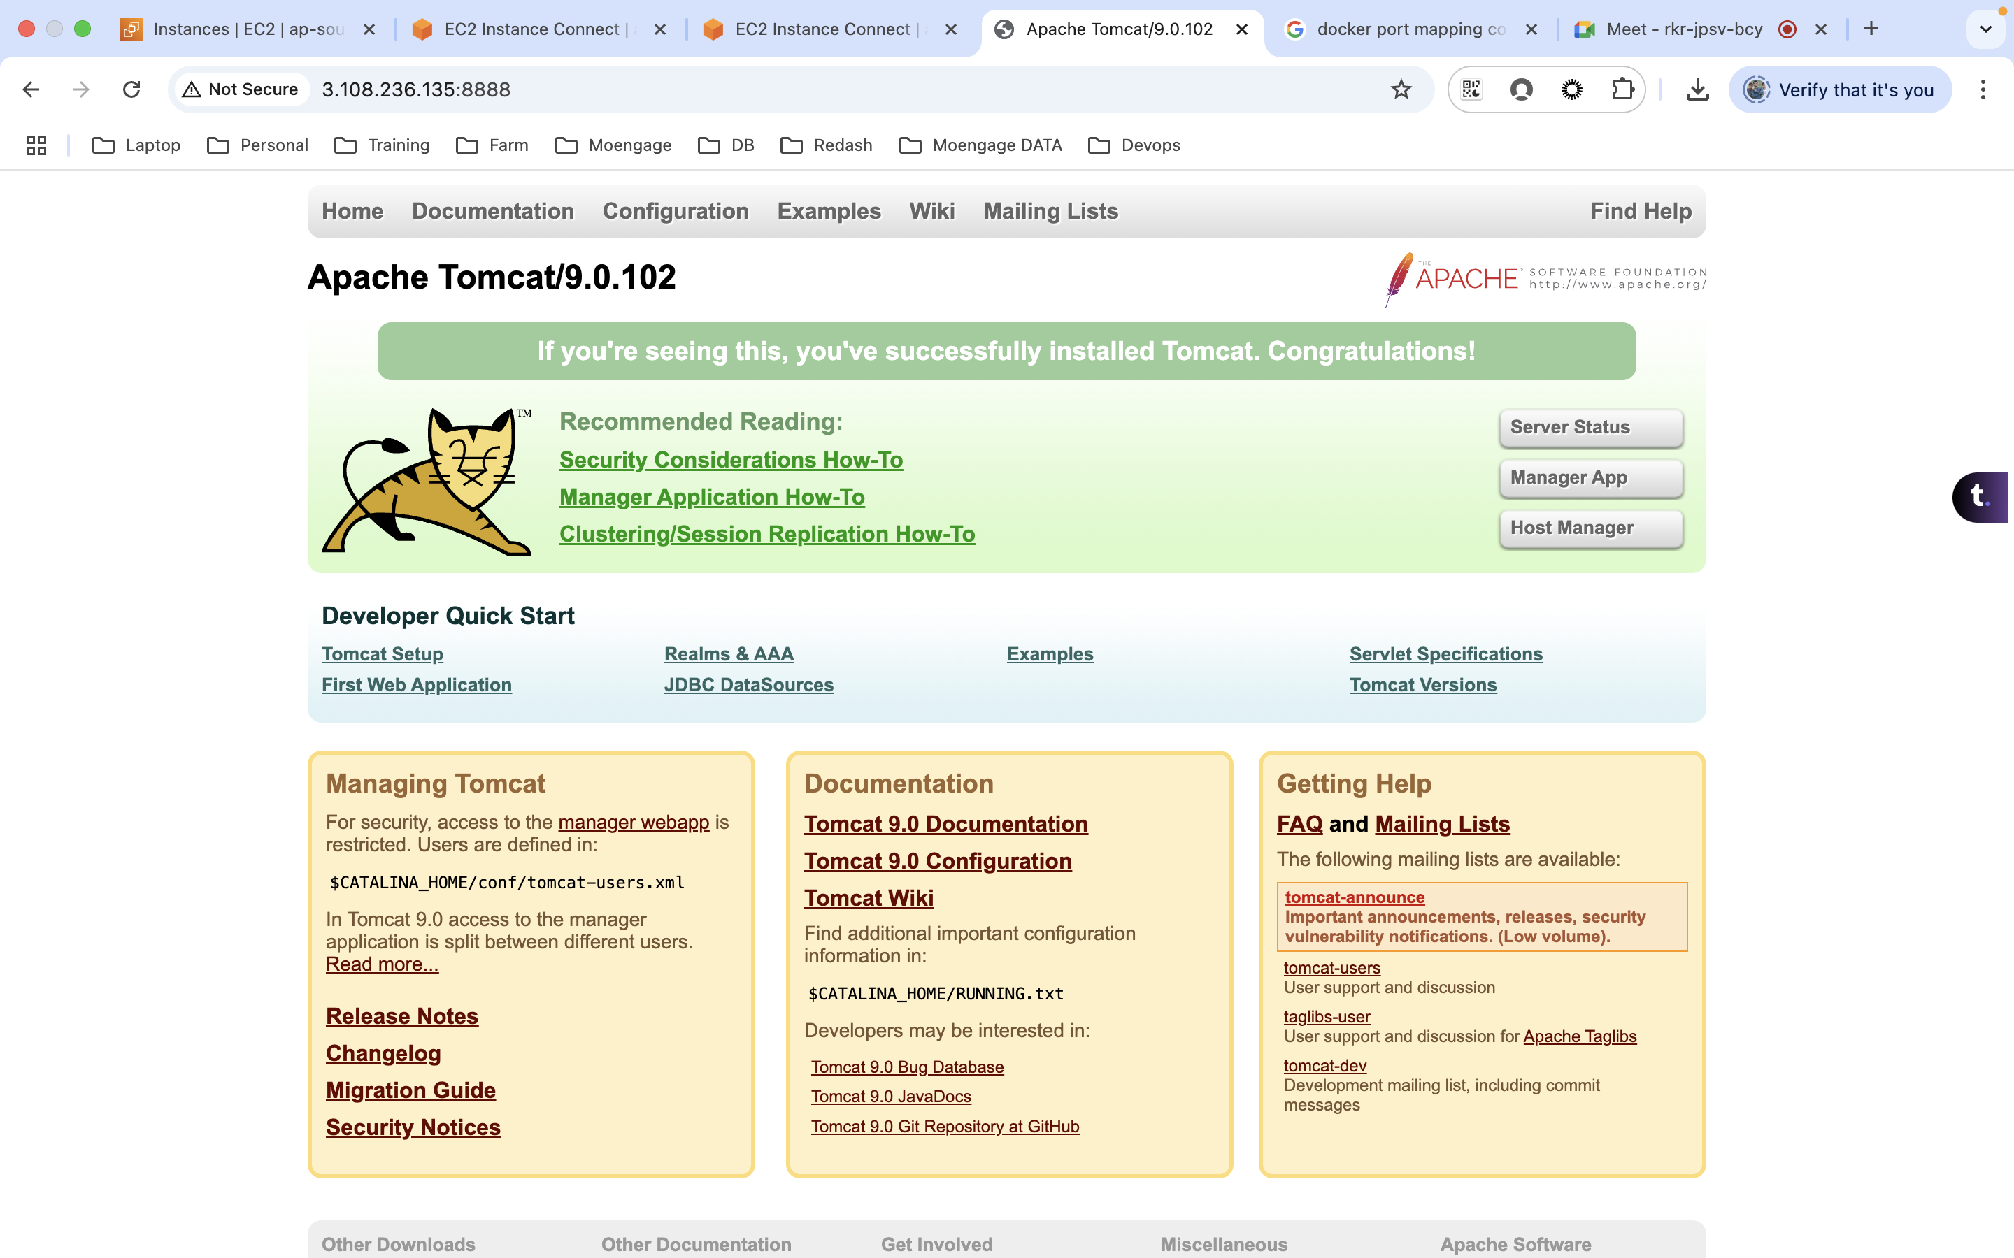

Destroyed and created a new container
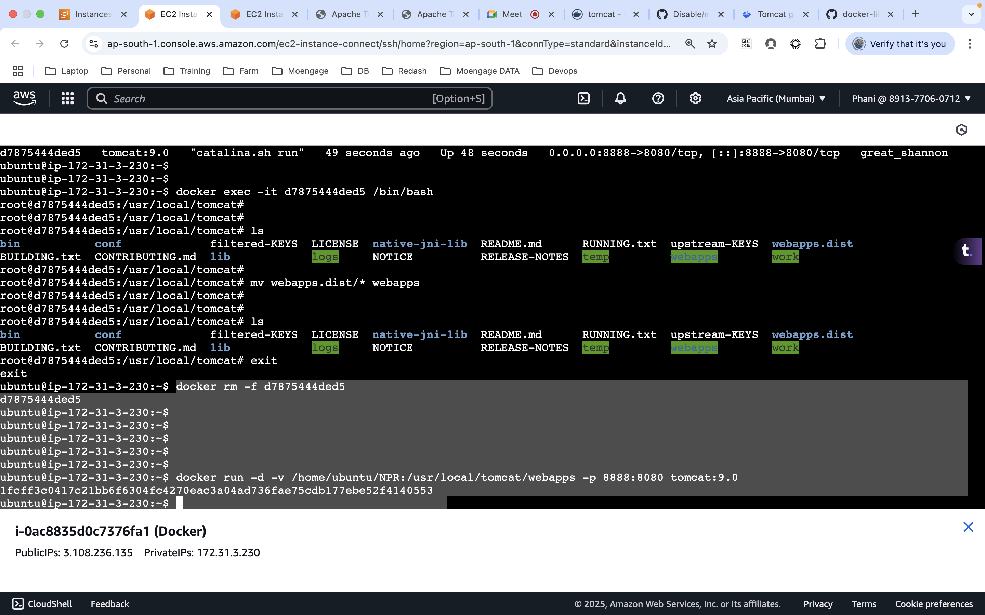

No need to make the changes at the webapps folder now.
